EBOLA IN CONTEXT: UNDERSTANDING TRANSMISSION, RESPONSE AND CONTROL

# **WEEK 1** STEP 1.18 BASIC CASE REPRODUCTION NUMBER AND SECONDARY ATTACK RATE

This quiz will check your understanding of concepts related to infectiousness and how it is measured.

## Question 1

How would you expect R0 for Ebola in an urban area to compare with the R0 for Ebola in a rural area?

## Answer

Select one:

1. R0 would probably be higher in an urban area
2. R0 would probably be higher in a rural area
3. R0 would probably be the same in both

## Question 2

Assuming that there is a primary case in all households, calculate the household secondary attack rate if there are 244 households with at least one susceptible individual, 827 total susceptible individuals within the households, and 511 of the susceptible individuals become ill.

## Answer

Select one:

1. 48%
2. 30%
3. 62%

## Question 3

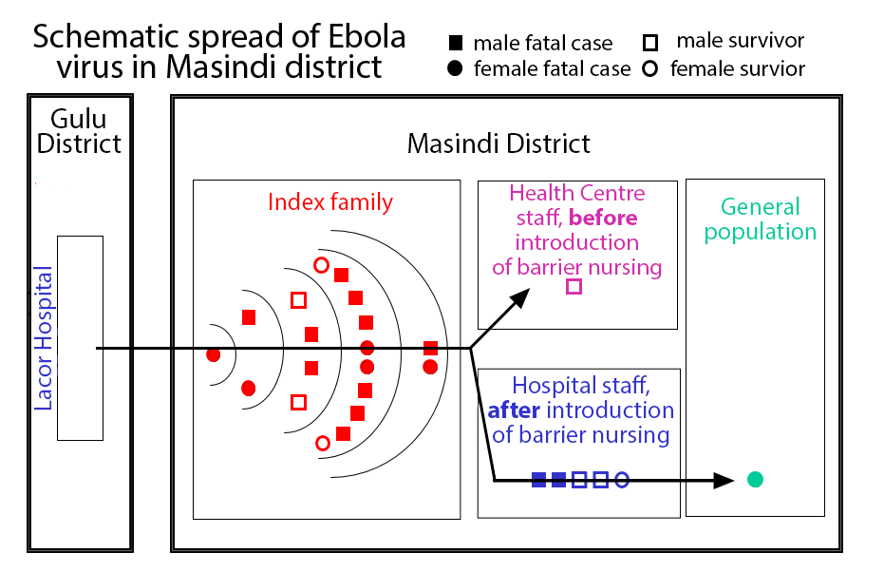

Image: [Borchert, et al.](http://www.biomedcentral.com/1471-2334/11/357/)

In an Ebola outbreak in Uganda in 2000, a health worker travelled back to her home in Masindi district. 18 members of her extended family became ill over several generations of transmission. Following the primary case, there were 2 secondary cases, 4 tertiary cases, 10 cases in the 4th generation, and 2 in the 5th.

What is the approximate value for R0 in the early stages of this outbreak?

## Answer

Select one:

1. 17
2. 6
3. 3
4. 2

# Feedback and correct answers

## Question 1

1. **R0 would probably be higher in an urban area (CORRECT)**

**Feedback: The infectious case is likely to have contact with more people in an urban population than in a rural population, so R0 is likely to be higher.**

1. R0 would probably be higher in a rural area

Feedback: Think about the likely number of effective contacts between people in urban vs rural settings.

1. R0 would probably be the same in both

Feedback: Is the number of effective contacts the same in both urban and rural settings?

## Question 2

1. 48%

Feedback: Remember that to calculate the secondary attack rate, you must take the number of susceptible individuals that had contact with an infected individual and became ill and divide that by the total number of susceptible individuals that had contact with an infected individual.

1. 30%

Feedback: Remember that to calculate the secondary attack rate, you must take the number of susceptible individuals that had contact with an infected individual and became ill and divide that by the total number of susceptible individuals that had contact with an infected individual.

1. **62% (CORRECT)**

**Feedback: 511 ill / 827 susceptible = 0.62 = 62%**

## Question 3

1. 17

Feedback: To calculate this, compare the numbers arising in each generation with the previous generation.

1. 6

Feedback: To calculate this, compare the numbers arising in each generation with the previous generation.

1. 3

Feedback: To calculate this, compare the numbers arising in each generation with the previous generation.

1. **2 (CORRECT)**

**Feedback: From one generation to the next there is an approximate doubling in cases numbers, so R0 is approximately 2. In the last generation there were probably few susceptible individuals left among the index family**

This material has been repackaged from a free, online course delivered by the London School of Hygiene and Tropical Medicine on the FutureLearn platform in 2015. Additional information about the course and its contributors can be found on [the School website](http://www.lshtm.ac.uk/study/freeonlinecourses/ebola/).

Future iterations of the course may feature slightly different material. Further live runs of this and other courses can be found on the platform. Please visit the [School’s FutureLearn webpage](https://www.futurelearn.com/partners/london-school-hygiene-tropical-medicine) for more details.

## CC license

## Ebola in Context: Understanding Transmission, Response and Control by the [London School of Hygiene & Tropical Medicine](http://open.lshtm.ac.uk/) is licensed under a [Creative Commons Attribution-ShareAlike 4.0 International License](http://creativecommons.org/licenses/by-sa/4.0/).